**Project Design Phase**

**Solution Architecture**

|  |  |
| --- | --- |
| Date | 28 june 2025 |
| Team ID | LTVIP2025TMID55291 |
| Project Name | **FreelanceFinder: Discovering Opportunities, Unlocking Potential** |
| Maximum Marks | 4 Marks |

**Solution Architecture:**

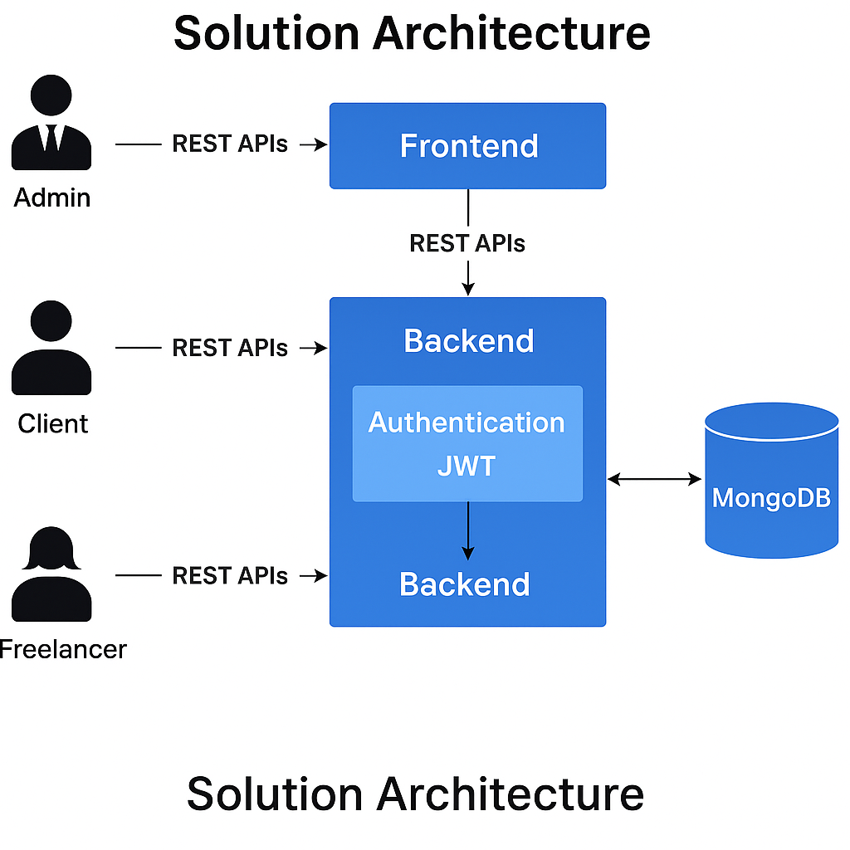

*Figure 1: Architecture and data flow of the voice patient diary sample application*